ВСЕРОССИЙСКАЯ ОЛИМПИАДА ШКОЛЬНИКОВ ПО АНГЛИЙСКОМУ ЯЗЫКУ

(МУНИЦИПАЛЬНЫЙ ЭТАП)

Возрастная группа: 7-8 классы

**LISTENING (10 points)**

***Time: 15 minutes***

**Part 1.** For items **1-5 y**ou will hear an expert giving a talk on blogs. Listen to the recording and complete the summary below. Write **ONE OR TWO WORDS** for each answer. You will hear the recording **twice**.

Blogs and the History of Blogging

A blog can perhaps be best described as a website that consists of a kind of journal that is regularly updated. Blogs cover a very wide variety of topics and many of them are personal diaries. Blogs are usually not 1. …………………. because they have interactive elements, which may lead to friendships or even 2. …………………. relationships between people.

The first 'blog' was probably created in 1994 by a student and he called it his ‘3. ………………….’. Similar websites were then created and these included both links and 4. ………………….. In 1999, someone changed the term used for these websites by creating the phrase ‘5. ………………….’, and therefore invented the term ‘blog’.

**Part 2.** For items **6-10** listen to the second part of the recording. Complete the flow chart below. Write **ONE WORD ONLY** for each answer. You will hear the recording **twice**.

Blogging Workflow - Advice

Decide what the frequency of your posts will be

Do some 6. …………………. before starting a post

As you compose the post, keep a record of 7. …………………. and links

After creating the post, add some 8. …………………. to it to improve searchability

Use social networking sites to announce a post you think is outstanding

Look at the 9. …………………. relating to the post

Don't simply say 10. …………………. to people who have responded to your post

Go on to other blogs and leave comments.

**Transfer your answers to the answer sheet.**

ВСЕРОССИЙСКАЯ ОЛИМПИАДА ШКОЛЬНИКОВ ПО АНГЛИЙСКОМУ ЯЗЫКУ

(МУНИЦИПАЛЬНЫЙ ЭТАП)

Возрастная группа: 7-8 классы

**READING (15 points)**

***Time: 15 minutes***

**Read the stories and complete the tasks below.**

*Why is it that teenagers and adults get bored so easily, but young children are able to think of endless ways to keep themselves entertained? Three people tell us about what they did as young children.*

Anthony

Well, when I was young my mum and dad were always playing classical music on CD. I liked the noise of this music - well, I think I just liked any noise basically. So I always tried to join in. I was only about three - much too young to play the piano or any other musical instrument. So I went to the kitchen, found a saucepan and a couple of wooden spoons. Then I took them to the room where my parents were listening to old composers like Brahms or Beethoven. And I just started hitting the saucepans with the spoons. I loved it, and spent ages doing this. I think it drove my parents crazy - they started taking me out into the garden and leaving me there to make all this awful noise! Still, I enjoyed myself.

**José**

In my childhood we didn't have many toys and things. We managed without a computer or anything like that. Didn't need one really – my brother and I were really creative, and just invented our own games all the time. My favourite was using my hands and feet to climb up the inside of doorways. I loved getting right up to the top and then jumping back down onto the floor. We played games to see who could climb up to the top the quickest, and who could stay there for the longest.

**Sergey**

Like Jos**é**, there weren’t a lot of toys in my family. But we did have quite a few dogs. Of course, when you’re a very young child, a dog seems like a huge animal. So my younger sister and I, we used to sit on them and ride them like horses! No helmets, no saddles, we just sat on them, and tried to make the dogs take us round the house. I was never very good at it - I think I weighed too much. I usually fell off, then just went and had some cake! But my sister became really good.

**Part 1.** Match the questions **1-3** with the answers **A-C.**

Who …

1. had competitions with other family members?
2. annoyed the other people in his family?
3. was too big to do something well?
4. Anthony
5. Sergey
6. Jos**é**

**Part 2.** Read the stories again. Write true (**T**), false (**F**) or not stated (**NS**).

1. The introduction says that little children are good at thinking of things to do.
2. Anthony was learning to play the piano.
3. Anthony talks about playing inside and outside.
4. Anthony learned to play classical music when he grew up.
5. Jos**é** had lots of computer games as a child.
6. Jos**é** and his brother created their own games.
7. Sergey wore a helmet when he was riding.
8. Sergey used to dislike cats.
9. Sergey says he was a better rider than his sister.

**Part 3.** What do the words **in** bold in the text refer to?

1. **them**
2. parents
3. saucepan and spoons
4. composers
5. **one**
6. childhood
7. computer
8. brother
9. **it**
10. riding dogs
11. weighing his sister
12. making cake

**Transfer your answers to the answer sheet.**

ВСЕРОССИЙСКАЯ ОЛИМПИАДА ШКОЛЬНИКОВ ПО АНГЛИЙСКОМУ ЯЗЫКУ

(МУНИЦИПАЛЬНЫЙ ЭТАП)

Возрастная группа: 7-8 классы

**USE OF ENGLISH (20 points)**

***Time: 20 minutes***

**Part 1.** For questions **1-10,** read the text below and think of the word which best fits each gap. Use only ONE word in each gap. Choose the words from the box below. There are **four extra words** in the box. Write your answers on the separate answer sheet.

|  |
| --- |
| *had also in consists leave out has not for comprises height find devote of* |

*The Sleeping Beauty* is often described as "an encyclopedia of classical dance". This three-act ballet (1) ……………………….. everything created by the genre of classical ballet over the three hundred years it has existed.

Marius Petipa, the god and hero of the 19th century St. Petersburg ballet, mastered all these aspects. By the time The Sleeping Beauty premiered in 1890, he (2) ……………………….. been the chief choreographer of the Mariinsky Theatre for 30 years. In The Sleeping Beauty, the 72-year-old choreographer showed that he was capable (3) ……………………….. radical innovations. His co-author was the composer Pyotr Tchaikovsky, who was at the (4) …………………………………. of his career, world famous and widely admired. It was

(5)……………………….. an easy collaboration: Petipa had meticulously drawn up a plan (6)………………...a four-hour-long ballet, presenting the composer with an assignment that set the nature of the music, its tempo, and even the number of bars in each number. Yet, Tchaikovsky managed to (7) ……………………….. inspiration even within these constraints – the music for The Sleeping Beauty is one of his best works. For his part, Petipa turned (8) ……………………….. to be capable of flights of broad imagination that he had not known with other composers he worked with.

The Sleeping Beauty (9) ……………………….. holds a special place in the history of Russian culture because legendary ballerina Anna Pavlova and artist Alexandre Benois decided to (10) ……………………….. their life to ballet after they first saw its production as children.

**Part 2.** For questions **11-15** complete the sentences with **animal**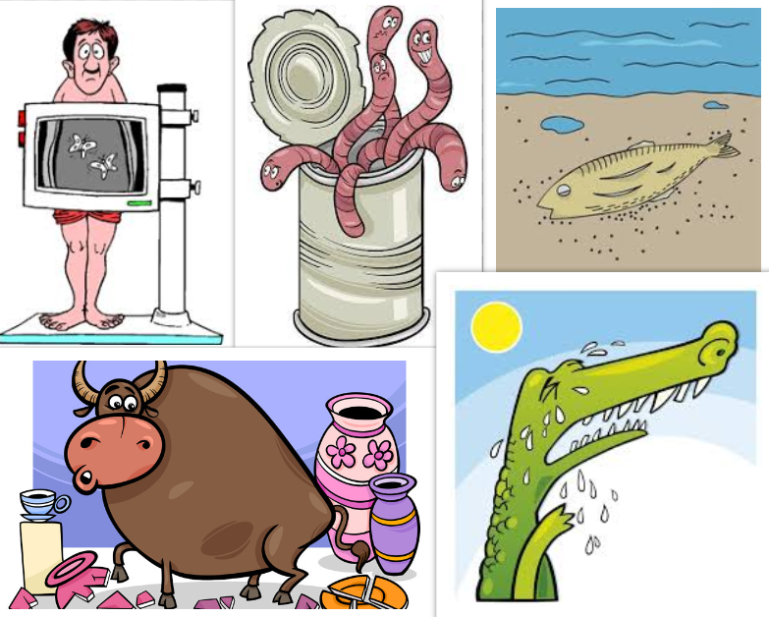 idioms. Use picture prompts below. The pictures are given in a jumbled order.

|  |  |
| --- | --- |
|  | **Idiom** |
| 11. |  |
| 12. |  |
| 13. |  |
| 14. |  |
| 15. |  |

11. I'm meeting her parents tonight, and I have a bad case of (11)……………………….. (4 words).

12. I felt like a (12)……………………….. (4 words) at my new school.

13. He shed a lot of (13)……………………….. (2 words). But we knew that this was a noisy, showy action.

14. Danny is like a (14)……………………….. (5 words) - don't let him near those sculptures.

15. Wanda didn't want to create unnecessary complications; she decided not to open up a

(13) ………………….. (3 words).

**Part 3.** A Word Ladder.

For items **16-20,** read the clues, then write new words by changing **ONE** letter in each word. **START at the BOTTOM and climb to the top.**

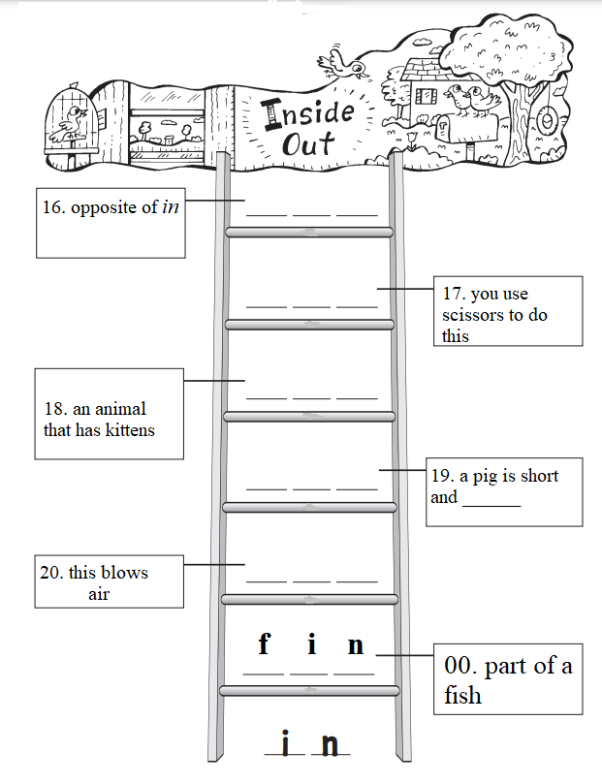

|  |  |
| --- | --- |
| **16.** |  |
| **17.** |  |
| **18.** |  |
| **19.** |  |
| **20.** |  |
| **00.** | fin |

**Transfer your answers to the answer sheet.**

ВСЕРОССИЙСКАЯ ОЛИМПИАДА ШКОЛЬНИКОВ ПО АНГЛИЙСКОМУ ЯЗЫКУ

(МУНИЦИПАЛЬНЫЙ ЭТАП)

Возрастная группа: 7-8 классы

**WRITING (10 points)**

***Time: 40 minutes***

Your school magazine is running a writing competition. Students are invited to submit short stories based on the pictures below.

You decide to take part in the competition. Your short story must have a title, a description of all the events in pictures **1-6**, and the following words:

* *furious*
* *threaten*
* *pace the floor*
* *suddenly*
* *embrace*

Write **18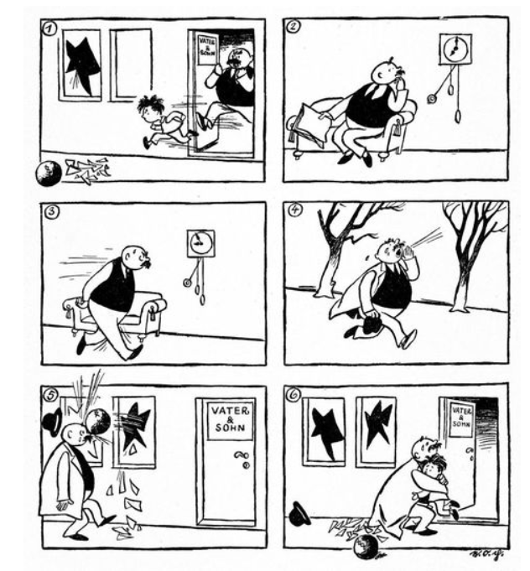0-220** words.

**Transfer your answers to the answer sheet.**