ВСЕРОССИЙСКАЯ ОЛИМПИАДА ШКОЛЬНИКОВ ПО АНГЛИЙСКОМУ ЯЗЫКУ
(МУНИЦИПАЛЬНЫЙ ЭТАП)
Возрастная группа: 7-8 классы

LISTENING (10 points)
Time: 15 minutes

Part 1. You are going to listen to someone talking about two websites. Listen to the recording and complete the notes. Write NO MORE THAN TWO WORDS AND/OR A NUMBER for each answer. You will hear the recording twice.

WEBSITES ABOUT FOOD
The History of Rice
Rice first grown: (1)………………….. years ago
Amount of rice produced every year: over (2) ………………….. tonnes
Number of calories in one serving of rice: (3)………………….. calories
Three things you can make from rice: drinks, glue and (4)…………………..

Yokohama Noodle Museum
Date museum opened: (5)…………………..
Day museum closed: (6)…………………..
Souvenir shop: on (7)………………….. floor; old (8)………………….. shown on TV
Number of noodle shops in the theme park: (9)…………………..
Journey time by train from Tokyo: (10)…………………..

Part 1
1. |  | 6.
2. |  | 7.
3. |  | 8.
4. |  | 9.
5. |  | 10.

Transfer your answers to the answer sheet.
ВСЕРОССИЙСКАЯ ОЛИМПИАДА ШКОЛЬНИКОВ ПО АНГЛИЙСКОМУ ЯЗЫКУ
(МУНИЦИПАЛЬНЫЙ ЭТАП)
Возрастная группа: 7-8 классы

READING (15 points)
Time: 15 minutes

Read the article and complete the tasks below.

WHAT SLANGUAGE DO YOU SPEAK?

Teens and slang
Slang is fun – it's always been part of English, making the language richer and more diverse. Teenagers in particular tend to use slang like their own private language. (2)………….. So is teenagers using slang something we should worry about? The real question is not whether teens should use slang or not but if they know when and how to use it. (3)………….. They claim that young people are increasingly unable to distinguish situations in which it’s acceptable to use slang from situations where they should use more formal language.

'Young people can't speak properly'
For some time now, teachers and educators have been complaining that teens don’t know how to express themselves in writing. They are so used to sending texts with abbreviations and no punctuation that they barely remember what standard written English is like. What is more, researchers have noticed that many young people are finding it difficult to communicate without using slang in formal contexts, such as the classroom or at work.

Banning slang in the classroom
In order to overcome the problem, one school in Manchester took the radical step of banning slang completely from the classroom. ‘It was clear that many students found it difficult to get through a sentence without saying “innit?” or “know what I mean?” explains Maria Nightingale, the school principal. Nightingale and the teachers in the school were worried about their students’ inability to use ‘normal’ English. (4)………….. Since the school banned slang, exam results have improved greatly.

Studying slang
St Francis Xavier School in London has taken a different approach – they’ve put slang on the curriculum and students learn to analyse slang and study its origins. (5)………….. Slang expert Tony Thorne believes that talking about slang helps people to develop a sense of ‘appropriacy’ with regard to language use. Appropriacy means using the right variety of language in the right context – for example, business jargon in business meetings, formal English in exams and slang with your friends

Slang – our new language?
However, many people feel that the way teens are using slang is part of a new social trend. They believe the profile of slang is changing. It is not that slang has become more popular but that it has become more public. Ten years ago, serious newspapers never printed slang, now it’s everywhere – in the press, on TV, in music. (6)………….. Will slang take over and become part of standard English? Only time will tell.

Part 1. Look at the title and paragraph headings in the text. What is the text about? For item 1 choose the best answer (A, B or C).
- slang in different countries
- teenagers using slang at school
- the function of slang in society

Part 2. Read the article and match the sentences A-F to the gaps 2-6 in the text. There is ONE extra sentence.
- They investigate the various functions of slang and its connection to identity, particularly for minority groups.
- For them, talking in slang is part of growing up and establishing a sense of identity.
- Slang is used as a form of protest.
- Some experts believe that they don't.
- It's almost impossible to avoid it.
- They believed it could stop their students from getting a good job or from doing well in exams.

Part 3. Read the article again. For items 7-13 write True (T), False (F) or Not Stated (NS).
7. Experts are worried because teens are using slang as a private language.
8. A lot of people think that teenagers today don't know how to write English.
9. The principal of the Manchester school said students found it hard to communicate using slang.
10. Students at the Manchester school are doing better in exams since slang was banned.
11. Some students in London are now studying slang at school.
12. Studying slang has helped the London students to improve their language skills.
13. Most people now believe that slang will soon become standard English.

Part 4. The title of the text contains the word slanguage which is an example of a blend or a portmanteau word. A blend is a word formed by combining two other words (slang + language = slanguage).
For items 14-15 look at the blends below, guess their meaning and find TWO words which denote:
14. the trend of cars and other vehicles becoming larger and heavier;
15. a long television advertisement that contains a lot of information and seems like a normal programme.
A. digilog  B. informercial |  |  | C. cosplay  D. motoshuttle |  |  |  | E. autobesity  F. carnapping |  | G. blook  H. autopilot
Part 1 |  | Part 2 |  |  | Part 3 |  |  | Part 4
1. |  | 2. |  |  | 7. |  |  | 14.
 |  | 3. |  |  | 8. |  |  | 15.
 |  | 4. |  |  | 9.
 |  | 5. |  |  | 10.
 |  | 6. |  |  | 11.
 |  |  |  |  | 12.
 |  |  |  |  | 13.

Transfer your answers to the answer sheet.
ВСЕРОССИЙСКАЯ ОЛИМПИАДА ШКОЛЬНИКОВ ПО АНГЛИЙСКОМУ ЯЗЫКУ
(МУНИЦИПАЛЬНЫЙ ЭТАП)
Возрастная группа: 7-8 классы

USE OF ENGLISH (20 points)
Time: 20 minutes

Part 1. Gap-Filling. For items 1-10, read the text below and think of the word which best fits each gap. Use only ONE word in each gap. Choose the words from the box below. There are four extra words in the box. Write your answers on the separate answer sheet.

in predecessor despite from off that but loose

whatever no ancestor against most lose

One of Suvorov’s (1)…………. talented and favorite pupils, Mikhail Kutuzov led Russian forces in the Patriotic War of 1812 (2)…………. Napoleon, and was thus the man who managed to break the “Grande Armée”.

Taking command in August 1812, Kutuzov continued to follow the tactics of his (3)…………., Barclay de Tolly, retreating deep into Russia and wearing down Napoleon’s army. (4)…………. the end, under pressure from the top military people and public opinion, the general field marshal was made to confront the “Grande Armée” in open battle, something (5)…………. occurred at the village of Borodino, 125 km (6)…………. Moscow.

In what became one of the most important battles of the Napoleonic Wars, Kutuzov did not throw himself hastily into combat, (7)…………. preferred to adopt a defensive position, allowing the French to (8)…………. valuable manpower making numerous attacks on Russian positions. The result was that (9)…………. side scored a decisive victory. The French emperor did not manage to smash the Russian Army. In the circumstances, it meant that his defeat in Russia was not far (10)………….. .

Part 2. Idioms. For items 11-15 complete the sentences with idioms. Use picture prompts below. The pictures are given in a jumbled order. Fill in TWO or THREE words to complete the sentences.



- He asked about their favorite movies to break ………………… during their first conversation. (2 words)
- I was so nervous about my exam, but my friend Mary was as cool ………………… and helped me stay calm by reminding me to take deep breaths and focus on one question at a time. (3 words)
- The coach encouraged the team before the championship game by saying, "Break ………………!" (2 words)
- Despite the noisy neighbours, she managed to sleep ………………… all night. (3 words)
- After graduating college, she found herself …………………, unsure whether to pursue a career or continue studying. (3 words)

Part 3. A Word Ladder. For items 16-20, read the clues, then write new words by changing ONE letter in each word.
START at the BOTTOM and climb to the top.
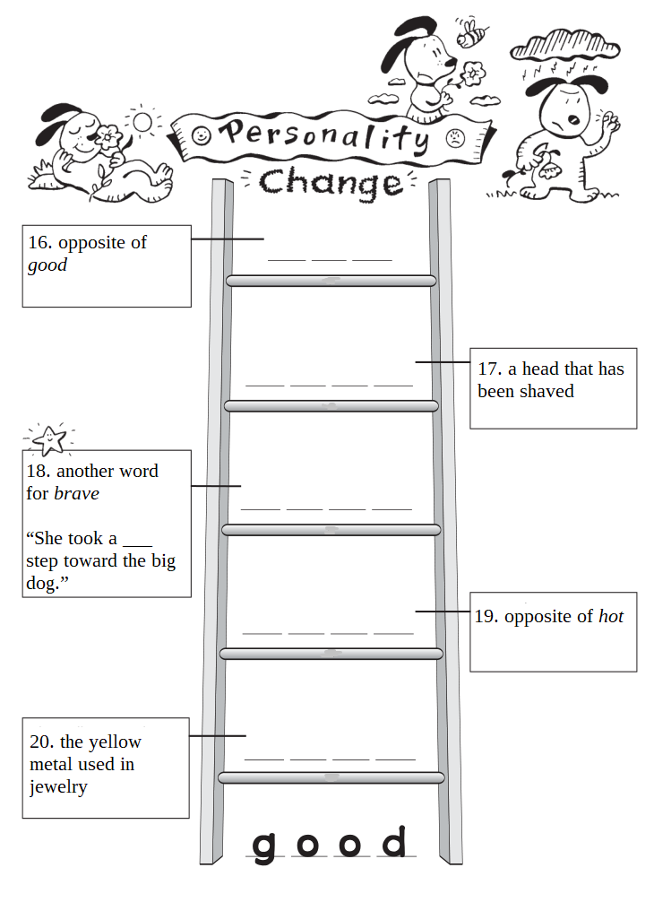

16.
17.
18.
19.
20.
00. | good

Transfer your answers to the answer sheet.

ВСЕРОССИЙСКАЯ ОЛИМПИАДА ШКОЛЬНИКОВ ПО АНГЛИЙСКОМУ ЯЗЫКУ
(МУНИЦИПАЛЬНЫЙ ЭТАП)
Возрастная группа: 7-8 классы

WRITING (10 points)
Time: 40 minutes

Your school magazine is running a writing competition. Students are invited
to submit short stories based on the pictures below.

You decide to take part in the competition. Write a story about two boys who helped the sheriff to arrest a bank robber. Your short story must have a title, a description of all the events in pictures 1-5, and the following words:

- armed
- to strike
- to tie
- to trip over
- handcuffs

Write 160-200 words.
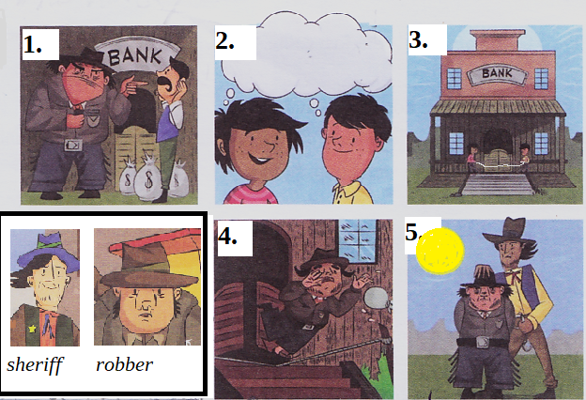

Transfer your answer to the answer sheet.

